COS 226 Algorithms and Data Structures Fall 2008

Midterm
This test has 7 questions worth a total of 60 points. You have 80 minutes. The exam is closed book, except that you are allowed to use a one page cheatsheet. No calculators or other electronic devices are permitted. Give your answers and show your work in the space provided. Write out and sign the Honor Code pledge before turning in the test.
“I pledge my honor that I have not violated the Honor Code during this examination.”
Problem | Score
1
2
3
4
Sub 1

Problem | Score
5
6
7
Sub 2

Name: Login ID: Precept: P01 12:30 Boaz
P02 3:30 Boaz
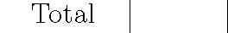
1
1. 8 sorting algorithms. (8 points) The column on the left is the original input of strings to be sorted; the column on the right
are the string in sorted order; the other columns are the contents at some intermediate step during one of the 8 sorting algorithms listed below. Match up each algorithm by writing its
number under the corresponding column. Use each number exactly once.
push iran axis axis bank whip axis bush bush axis poll iraq bank bank duck vice bank iran iraq bank iran poll bear bear axis vote duck bank iran bear iraq push bull bill bear veto evil fdic chad bill bank axis duck bull chad town fdic axis bank bull fdic bank evil bush fdic pork hall evil fdic bush axis evil fdic cage bill iraq iran duck axis cage evil fdic hall chad cage iraq iraq chad evil chad lame duck iran duck iraq race lame hall cage duck duck hall iraq evil iraq poll poll bull duck evil town lame iraq fdic bull spin push bear bill fdic hall town iraq flag evil iran town cage hall flag iraq bear lame iraq lame iraq iraq bill flag free iraq bull poll iraq iraq chad iraq free free hall bull iraq push poll bush iraq bull flag bull iran bear iraq town iran flag iraq bear iraq bear iraq veto free flag veto pork evil veto iraq iraq iraq race race free race jobs lame race iraq race iraq free veto jobs free free free free iraq iraq iraq whip whip race whip hall duck whip iraq whip iraq vice flag spin vice push bank vice jobs vice jobs jobs jobs veto jobs poll jobs jobs spin jobs lame spin spin vice spin iran push spin vice spin poll flag vice whip hall iraq flag flag pork iraq pork pork bill bill pork veto hall pork vote pork push vote cage bush vote race fdic vote whip vote race bill pork cage iraq spin bill bill race town spin cage vote chad push iraq cage cage veto lame town chad bush iraq lame vice axis chad town iraq veto iraq chad iraq iraq vote bull iraq lame poll vice bush iraq pork town town bush bush poll push vote iraq iraq vote iraq whip bear iraq push veto whip
0 1
(0) Original input | (4) Shellsort | (7) Quicksort
(1) Sorted | (13-4-1 increments) | (standard, no shuﬄe)
(2) Selection sort | (5) Mergesort (top-down) | (8) Quicksort (3-way, no shuﬄe)
(3) Insertion sort | (6) Mergesort | (9) Heapsort
 | (bottom-up)

2. Sorting equal keys. (6 points)
Suppose that you are sorting an array containing the following 7 equal keys (the subscript is not part of the key—its purpose is to uniquely identify each of the equal keys).
A0 A1 A2 A3 A4 A5 A6
What is the result of running the standard version (from the Sedgewick textbook) of each of the following sorting algorithms?
Insertion
Selection
Shellsort (13-4-1 increments)
Mergesort (top-down)
Quicksort (no shuﬄe)
Heapsort

3. Analysis of algorithms. (8 points)
(a) Big-Oh notation is less precise than tilde notation at describing the growth of a function because:
I. Big-Oh notation suppresses the coeﬃcient of the highest order term.
II. Big-Oh notation provides an upper bound on the growth of a function, but does not provide a lower bound.
III. Big-Oh notation suppresses lower order terms, so it only describes the limiting behavior of a function for large values of N.
Circle the best answer.
(a) I only. (d) I, II and III.
(b) I and II only. (e) None.
(c) I and III only.

(b) Suppose that your symbol table implementation supports the insert and search operations in amortized 4 lg N compares.
I. Starting from an empty data structure, any sequence of N insert and search operations uses at most 4N lg N compares. Which of the following are true? Circle the best answer.
II. Any sequence of N insert and search operations uses at most 4N lg N compares.
III. Starting from an empty data structure, the expected number of compares to perform N insert and search operations is 4N lg N, but there is a (small) probability that it will take 5N lg N compares (or more).
(a) I only. (d) I, II and III.
(b) I and II only. (e) None.
(c) I and III only.

4. Binary heaps. (8 points) Consider the following max-heap.
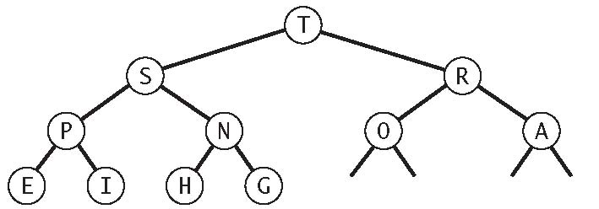
(a) Draw the heap that results after inserting the key Z.
(b) Draw the heap that results after deleting the maximum key from your answer to (a).
(c) True or false: given any binary heap with N distinct keys, the result of inserting a key larger than any of the N keys, and then deleting the maximum key yields the original binary heap.

5. Ordered-array implementation of a set. (8 points)
Suppose you implement the set data type using an ordered array. That is, you maintain the N keys in the set in ascending order in an array.
What is the order of growth of the worst-case running time of each of the operations below. Write down the best answer in the space provided using one of the following possibilities.
√
1 log N NNN log NN2
add(key) | add the key to the set
contains(key) | is the key in the set?
ceiling(key) | smallest key in set ≥ given key
rank(key) | number of keys in set < given key
select(i) | ith largest key in the set
min() | minimum key in the set
delete(key) | delete the given key from the set
iterator() | iterate over all N keys in the set in order

6. Red-black trees. (8 points) Consider the following left-leaning red-black tree.

Add the key Z, then add the key B. Draw the resulting left-leaning red-black tree.
7. Line intersection. (14 points)
Given N lines in the plane, design an algorithm to determine if any 3 (or more) of them intersect at a single point.
For simplicity, assume that all of the lines are distinct and that there are no vertical lines.
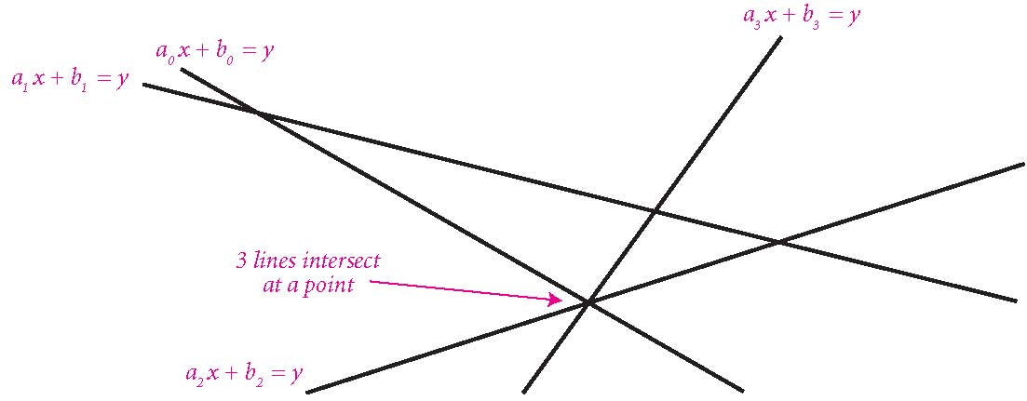
When we ask you to design an algorithm, give a crisp and concise English description of your algorithm—don’t write Java code. Your solution will be graded for correctness, eﬃciency, clarity, and conciseness.
(a) We specify a line by two numbers a and b such that a point (x, y) is on the line if and only if ax + b = y. Suppose that you are given two lines a0x + b0 = y and a1x + b1 = y. Design a constant-time algorithm that determines if the two lines intersect and, if so, ﬁnds the point of intersection.
Assume that you can perform arithmetic operations with arbitrary accuracy in constant time. That is, don’t worry about ﬂoating-point precision.
(b) Given an array of N lines, design an O(N2) algorithm to determine if any 3 (or more) of them intersect at single point. For partial credit, design an O(N2 log N) algorithm.
Assume that you have access to a hash table in which the insert and search operations take constant time.
(c) How would you modify your algorithm in (b) if you needed to output all sets of 3 (or more) lines that intersect at a single point. Output each maximal set exactly once.

